Organization Name:
Harlem Warrior Women Storytellers (HWWS)
Truth Telling and Sacred Memories from Community Building Struggles, Our Authentic Stories and Experiences -- A Community Building Retrospective 1993-Present
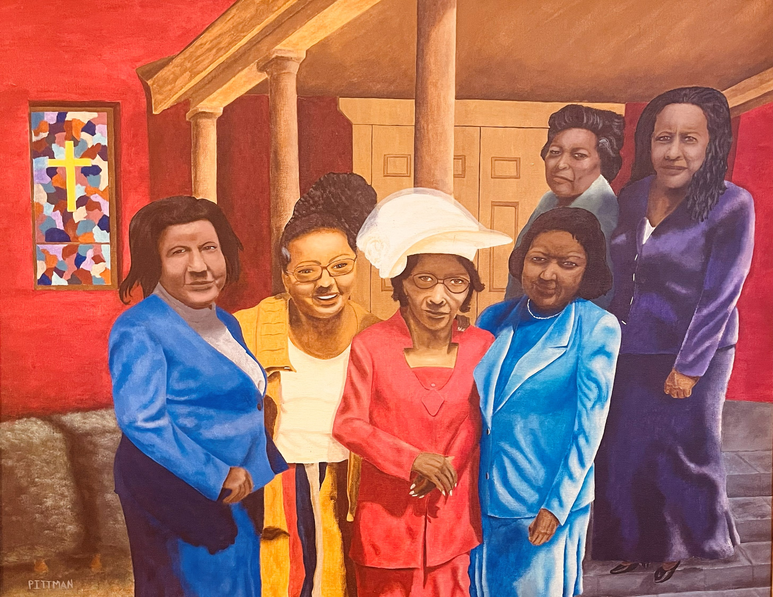

Our Story
Five women who worked together in a Harlem region of West 119th Street through West 124th Street, 5th Ave. – Frederick Douglas Blvd, beginning 1993 through 2004, met in April 2022 to fellowship with each other after 20 years. The purpose was simple: catch up with each other’s lives and see what we’d been doing over the years. We soon realized that there were so many collective memories, stories lessons, and authentic knowledge among the group: over 300 years. As we talked and enjoyed personal and collaborative stories, over a fabulous meal, we realized our collective body of knowledge should be shared with others. Essentially, our grassroots community organizing stories, lessons and knowledge should be shared with others in a way that support neighborhood change. Hence, we set our first meeting to develop a mission, purpose and plan for our work.

Mission and Purpose:
Harlem Warrior Women Storytellers held its first meeting in May 2022. The project set out to gather their individual, collective and collaborative stories (in their own words) from the community change work performed in transforming a neighborhood within the Harlem Community ranging from West 119th Street through West 124th Street, 5th Ave. – Frederick Douglas Blvd, during the period beginning 1993 to present. The work tells the stories of five Harlem Women that share their grassroots community organizing stories, their lives, their experiences, their expectations, and results from their work as community power change agents. Through this process, the women share lessons learned from their stories. The women’s reflections and analysis include the following:
- changes that happened in their homes and families;
- changes in their lives and how those changes affected their lives;
- changes in their community during the period beginning1993-present time;
- inspirations or motivations that triggered their involvement in community power change work, their own individual start point;
- practices, beliefs and / or principles they held as they began their involvement in the work;
- community / personal relationships in the beginning of the work—those captured during the work—those they enjoy today;
- what was gained, what was lost, what was forgotten—their feelings about it
- how change was achieved and the impact it has made on their lives, their families and their community.
This project will create an environment for grassroots people who are the subjects of community power change work, to give their own untainted and authentic accounts of their involvement in the work, through individual and collaborative reflective stories. These stories will be personal and inclusive of hopes, dreams, struggles, failures, successes; resulting in lessons from their individual and shared journey. Stories and lessons will include following categories:
- Individual Personal and Professional Growth and Development Stories
- Collaborative and Personal Community Power Change Stories and Lessons
- Who they were Then and who you are Now Stories
- What was the community like then and what is the community like now—how did / do you fit in.

Our Goals and Vision
- Focus of project will spotlight community residents’ individual and collaborative stories of community power change work and personal growth and development while participating in the work of Harlem Children’s Zone’s Community Pride, beginning 1993 – present
- Develop Critical events and build Story Bylines / Boards about resident involvement, community, and civic engagement, both personal and individual, 1993-present
- Draw learning lessons from stories and work during this period to share with others
Our Name
Harlem Warrior Women Storytellers (HWWS)
Truth Telling and Sacred Memories from Community Building Struggles: Our Authentic Stories and Experiences -- A Community Building Retrospective 1993-Present
Our Core Values and Belief
- The Importance of community members engaged in grassroots organizing that affect their lives to tell their stories in their own authentic voices
- Great merit in using reflective and guided process methods in uncovering tacit knowledge that people hold
- The benefits of using storytelling circles to build stories using people who have shared experiences
- The importance of developing lessons and exercises from story experiences for models of replications
- The importance of encouraging people in grassroots movements / organizing to record or capture their work
- The value of deepening public awareness and understanding the way in which local citizens in neighborhoods come together not only in rebuilding grassroots methods in their community, but also forging human bonds of trust and friendship among neighbors

Outcome Products (In Progress)
- Podcasts
- Educational YouTube clips
- Educational publications, books, individual and / or collective booklets of stories and lessons, etc
- Seminars, lectures, learning conferences, etc.
- PBS Documentary

